**Desain Database Kelompok 14 Manpro**

Flowchart proses:

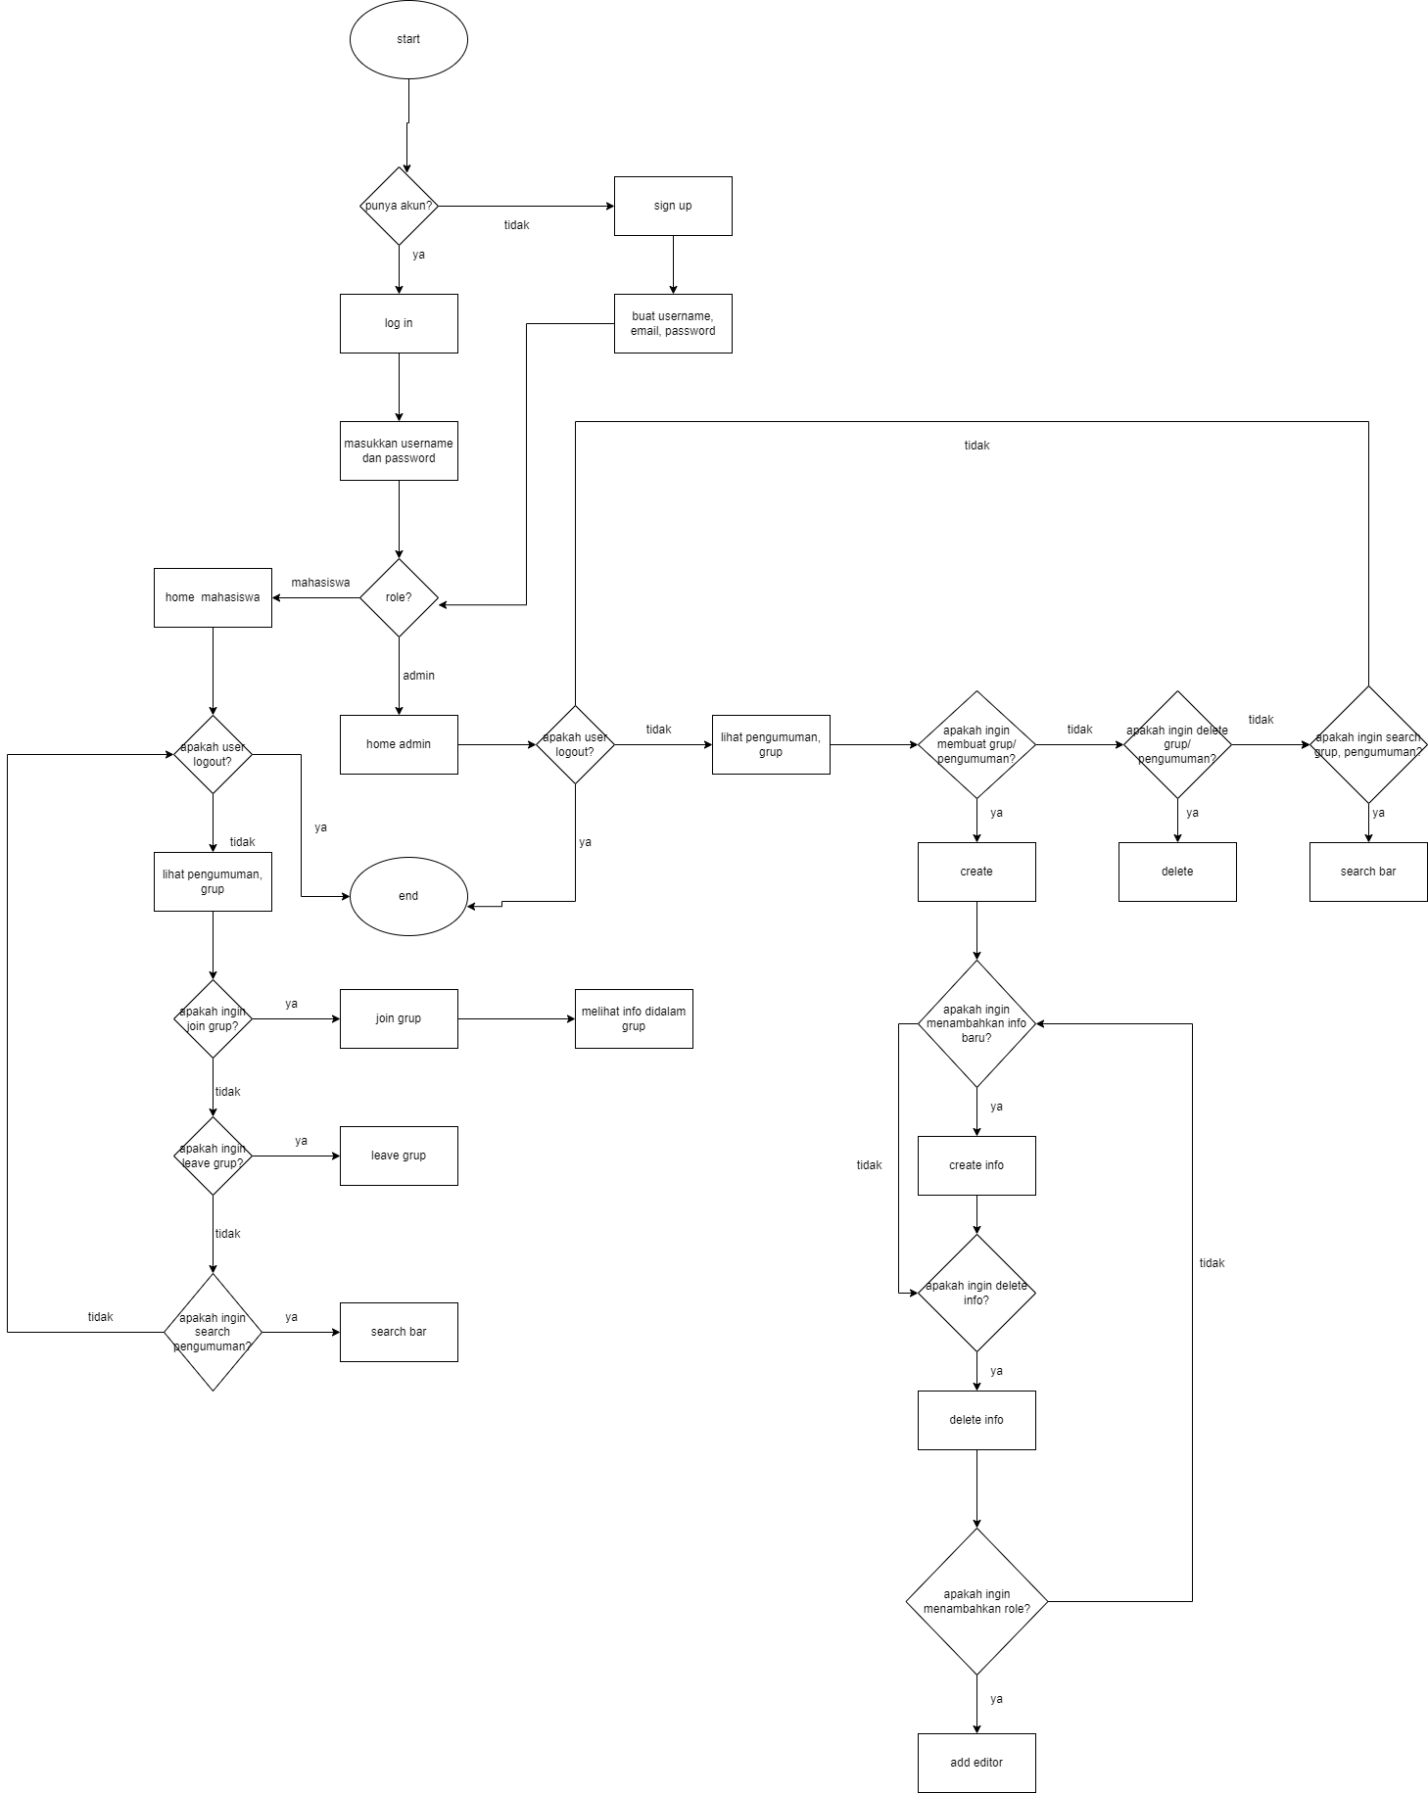

ERD:

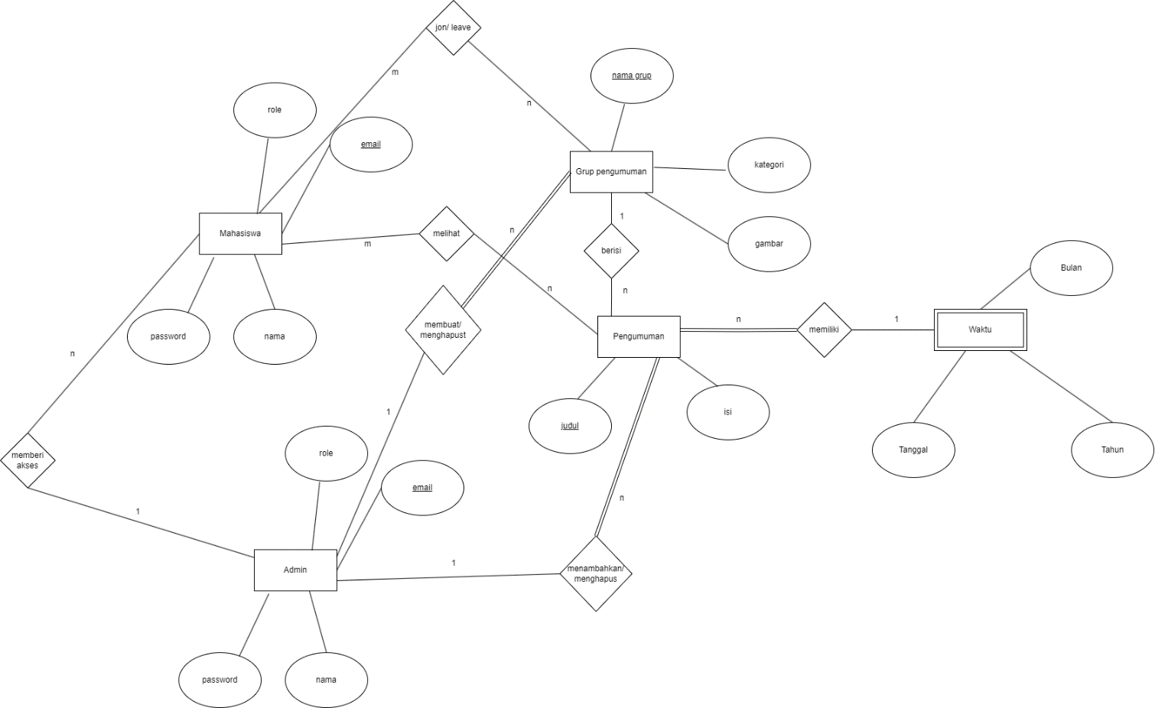

DFD:

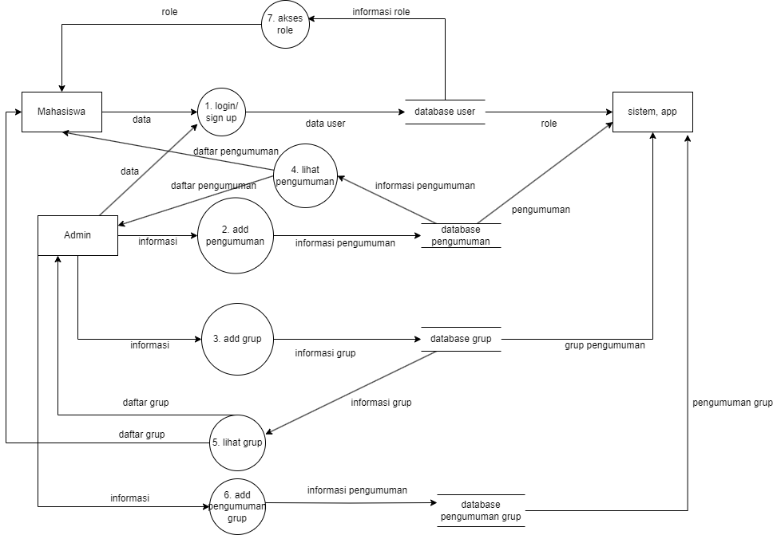

Mapping:

|  |
| --- |
| **Entity** |
| Pengumuman |
| Grup |
| Admin |
| Mahasiswa |
| Waktu |

|  |  |  |  |
| --- | --- | --- | --- |
| **Entity kuat** |  |  |  |
| Pengumuman | |  |  |
| **Judul (PK)** | Isi |  |  |
|  |  |  |  |
| Grup pengumuman | | |  |
| **Nama grup (PK)** | Kategori | Gambar |  |
|  |  |  |  |
| Admin | | | |
| **Email (PK)** | Nama | Role | Password |
|  |  |  |  |
| Mahasiswa | | | |
| **Email (PK)** | Nama | Role | Password |
|  |  |  |  |
| **Entity lemah** |  |  |  |
| Waktu | | | |
| **Judul pengumuman (FK)** | Tanggal | Bulan | Tahun |

|  |  |  |  |
| --- | --- | --- | --- |
| **Relasi 1:n** |  |  |  |
| Memberi akses | | | |
| **Email (PK, FK)** | Role | Nama | Password |
|  |  |  |  |
| Menambahkan, menghapus pengumuman | | |  |
| **Judul (PK)** | **Email (FK)** | Isi |  |
|  |  |  |  |
|  |  |  |  |
| Berisi | | | |
| **Judul (FK)** | **Nama grup (PK)** | Kategori | Gambar |
|  |  |  |  |
| Membuat, menghapus grup | | | |
| **Nama grup (PK)** | **Email (FK)** | Kategori | Gambar |
|  |  |  |  |
| **Relasi m:n** |  |  |  |
| Melihat | |  |  |
| **Email (FK)** | **Judul (FK)** |  |  |
|  |  |  |  |
| Join, leave | |  |  |
| **Email (FK)** | **Nama grup (FK)** |  |  |

Figma:

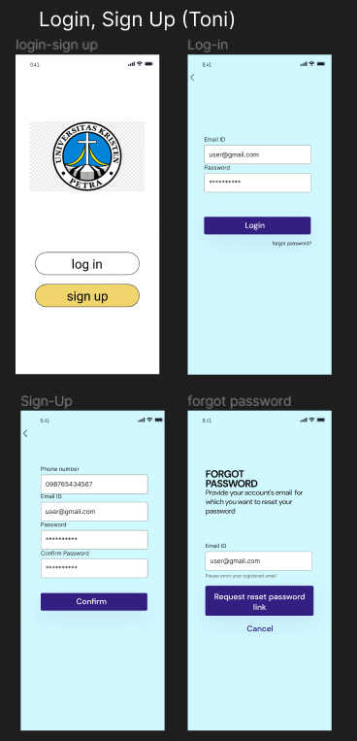

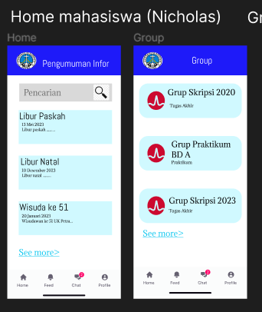

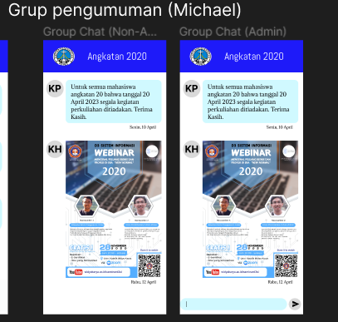

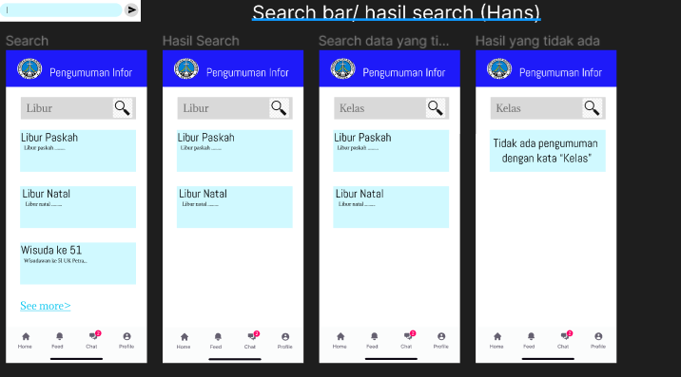

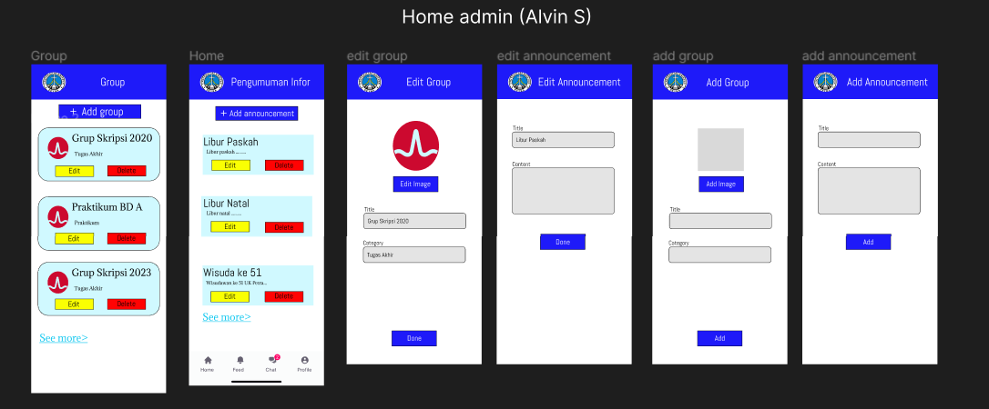

User flow:

Mahasiswa:

Login/ signup -> home -> lihat pengumuman, grup -> (search bar) -> (join grup) -> (lihat pengumuman dalam grup)

Admin:

Login/ signup -> home -> lihat pengumuman, grup-> (search bar) -> (create grup) -> (add pengumuman) -> (edit, delete grup, pengumuman) -> (add pengumuman grup) -> (add role)